**Using testosterone Gel as Part of HRT**

**Introduction:**

This leaflet is for patients who have been prescribed testosterone replacement. It tells you the reasons why it is used , how to use it and the possible risks.

**You must be on estrogen HRT when you use testosterone to minimise the risk of side effects**

**Why do we give it?**

A lack of testosterone may result in sexual problems such as low sex drive, issues around arousal and orgasm. It is important to be aware that there are many other factors involved in normal sexual function and testosterone plays only a small part in this.

There are no studies testing if it helps with other symptoms such as lack of energy.

**How is it given?**

At the moment there are no specifically medically licenced testosterone preparations for women in the UK. This means all currently available preparations are ‘off licence’

These products were designed and tested for men and are not licensed for use in women.The British Menopause Society and NICE approve use in women and have issued guidance on the correct dose.

**Are there any side effects or risks?**

As with all treatments, there will be side effects in some people. These are unusual with testosterone as long as you **don’t use more gel than is recommended.**

A very few women notice skin changes (usually becoming more greasy or spotty) and occasionally an increase in body hair.

Rarely there can be deepening of the voice and enlargement of the clitoris. These changes are not reversible. Even less likely are abnormalities of liver function.

These adverse effects can be minimised by monitoring the levels of testosterone in the blood, but this cannot be guaranteed to avoid side effects.

Taking testosterone is associated with a reduction in high-density lipoprotein (HDL or ‘good’) cholesterol, but there does not seem to be any increased risk of heart attacks or strokes.

The effect of testosterone therapy on other health outcomes for perimenopausal women is not known.

**How do I use testosterone replacement?**

You are recommended to use:

**Tostran 2% Gel 1 pump every other day**

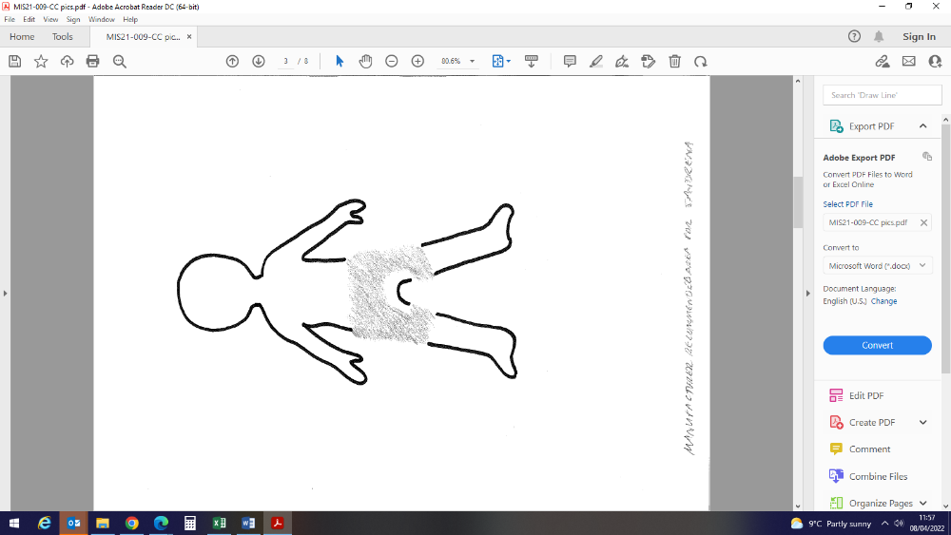Rub it in to clean dry skin on the upper outer/inner thigh or the lower abdomen .

Rub it in gently with a finger until it is dry.

Wait 2 hours to wash the area otherwise you may not absorb the full dose

Wash your hands immediately with soap and water after application of gel.

**How am I monitored? Do I need blood tests?**

Before starting testosterone replacement we would usually do a blood test to check your baseline level. After starting the replacement we would suggest a repeated blood test 2-3 months later. It will check that you are not having too much testosterone replacement.

Please don’t put any gel on before coming to your blood test appointment as this can make the level look too high. You can put it on afterwards.

**Keeping other people safe**

Testosterone gel can be transferred to other people by close skin to skin contact. This could be harmful especially in children. Avoid transfer by wearing clothes to cover the area you put the gel on, and bathing or showering prior to contact.

If contact does occur, the testosterone can be washed off the other person with soap and water.

**Further information:**

**Royal college of obstetricians and gynaecologists**

https://www.rcog.org.uk/for-the-public/browse-all-patient-information-leaflets/treatment-for-symptoms-of-the-menopause/

**Women’s Health Concern**

https://www.womens-health-concern.org/help-and-advice/factsheets/testosterone-for-women/