Sayana Press for self administration

Patient Information Leaflet

You have chosen to give yourself your contraceptive injection

Information is on https://www.nhsinform.scot/healthy-living/contraception/contraceptive-injection
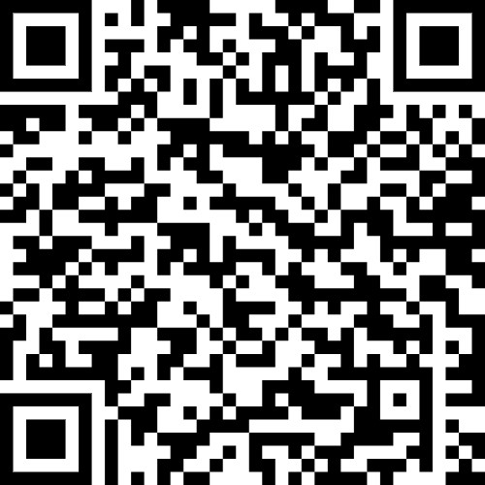

Read the instructions in the leaflet in the box carefully or watch this video on-line before giving yourself an injection

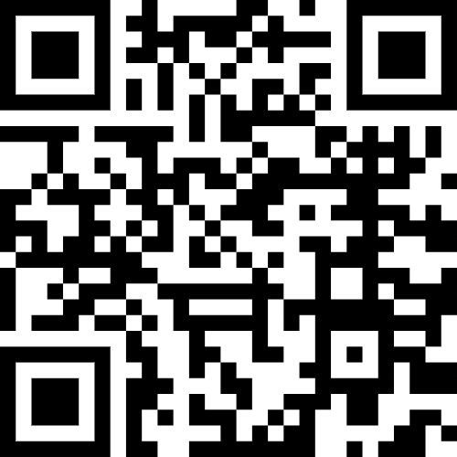

Give yourself an injection every 13 weeks. Set a reminder on your phone!

If you forget to give yourself the injection telephone the sexual health clinic for advice, contact number below.

If the injection site is sore, red and/or has pus coming out you must see a doctor or nurse.

If you have a sharps box then you must keep it safe:
- Keep your sharps box out of the sight and reach of children and pets.
- Keep the lid closed ( but not locked) when not being used,
- Don’t fill above the fill line
- If you have filled the box to the fill line, then you should bring it back to a sexual health clinic or GP practice for disposal.

Clinic phone number 01294 323226

##NHS Ayrshire & Arran CCard App in Apple and Android App stores.#

