Patient
Label

What Matters to You
in Choosing
Surgical Tubal Sterilisation?

Tubal Sterilisation - Patient Decision Aid

Please complete and return the form to a member of staff

Contents

A) Why complete this form? 3
B) My Alternative Options 4
C) My Values - What matters to me? 5
D) Tubal Sterilisation Options 6
E) My sterilisation choice 7
F) References 9

- Why complete this form?

Introduction

We are working to improve Person-Centred Care for women/people with a womb who are considering surgical sterilisation. It is important that the type of treatment chosen is right for you. As well as being safe and effective, treatment should focus on your individual needs and preferences as much as possible.

We know that by finding out more about you, we can improve shared decision making and subsequently the overall outcome of the treatment you choose. During shared decision-making, it is important to establish with your health-care provider (e.g. doctor/surgeon, nurse) ‘what matters to you’.

We would like to ask you to complete the forms on pages 5 and 7. When completed please give it to a member of staff or post back to the address on page 1.

Having this information about your routine activities allows us to adapt our care to suit your needs.
Who should complete this form?
Women/people with a womb requesting tubal sterilisation for permanent contraception, either during a Caesarean section or as a separate surgical procedure.
What happens after I complete this form?
Once we have received your completed form, our team will consider and discuss your choices with you.
What if I do not want to give the information?
It is entirely your choice if you do not feel like sharing the information with us. Please inform a member of staff so we do not bother you by repeatedly asking again. If you change your mind in the future and would like to complete the form, we will be happy to accommodate this.
Can I change the shared information once I have completed it?
Yes, we recognise that ‘what matters to you’ may change during the decision-making process. You can change what you provide at any time as it is your shared information.


Tubal Sterilisation – Patient Information Leaflet

QR code

- My Alternative Options

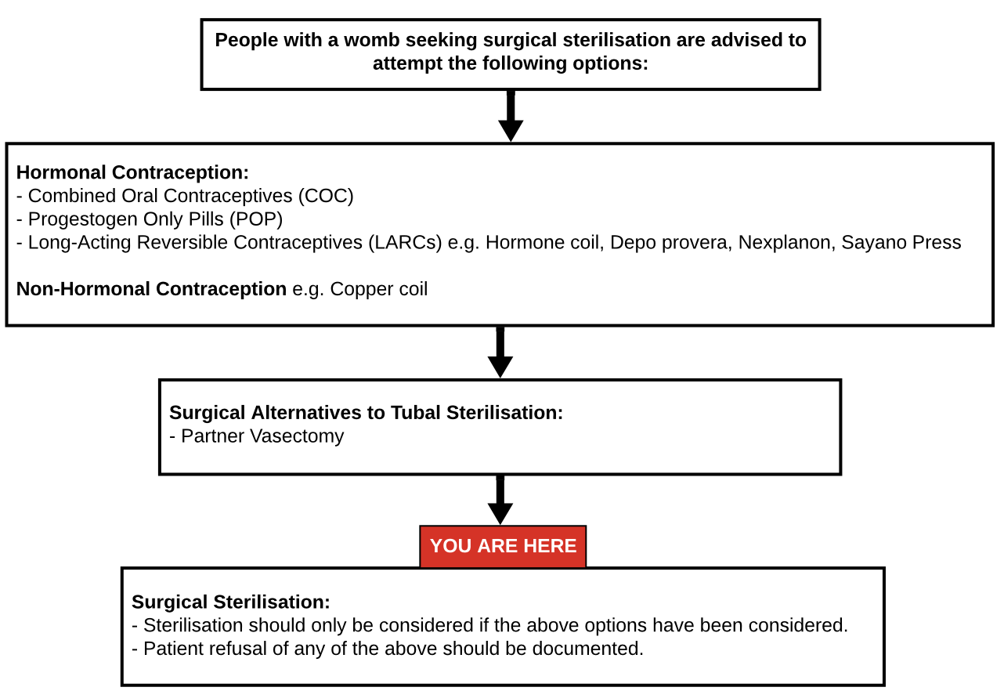

* Please ask your doctor for the specific leaflet of the treatment(s) you are considering.

Referral to a different clinician (or a different hospital) may be required, depending on availability of treatment options.

- My Values - What matters to me?

- Please let us know what is important to you from the list of values below.
- A member of staff can help you complete it if you wish.
- Some things that matter to you may be physical, psychological, emotional, social or it could be something completely different. There are no “right or wrong” answers, as it is about you.

Please add a value from 0 to 10 (0 = low priority, 10 = high priority) next to each of the following values:

What matters to you? | Importance out of 10
Lowest chance of another pregnancy including tubal ectopic pregnancy | 0 1 2 3 4 5 6 7 8 9 10
Least damage possible to my tubes | 0 1 2 3 4 5 6 7 8 9 10
Avoiding foreign body / synthetic material / permanent implant | 0 1 2 3 4 5 6 7 8 9 10
Lowest risk of late / long-term complications such as clip migration… | 0 1 2 3 4 5 6 7 8 9 10
Potentially reducing my risk of developing ovarian cancer in the future | 0 1 2 3 4 5 6 7 8 9 10
Other (please specify)  _______________________ | 0 1 2 3 4 5 6 7 8 9 10

* Reversal procedures are not available on the NHS, only in private hospitals.

- Tubal Sterilisation Options

What are the main advantages and disadvantages of the main two keyhole sterilisation options?
Treatment Option | Main Advantages | Main Disadvantages
Keyhole  Filshie Clip Sterilisation  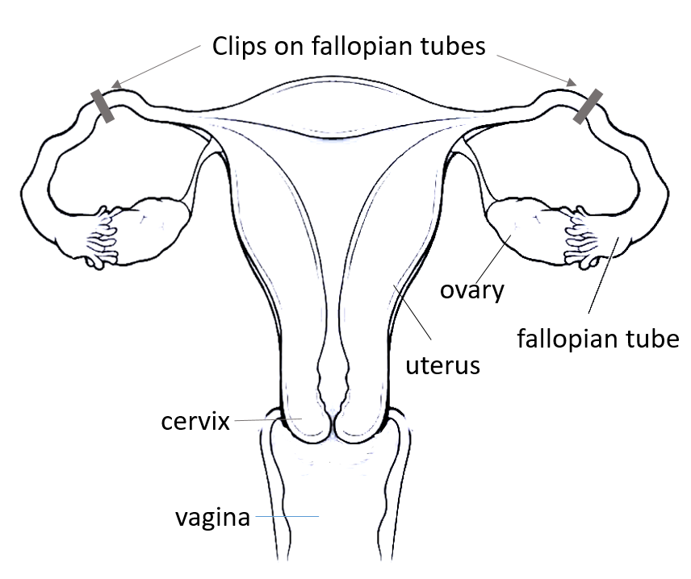  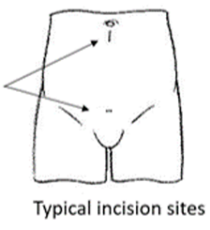  One or two clips made of silicone/titanium device is applied to permanently block the tubes | - Most common tubal sterilisation procedure  - 99.5% success rate (1:200 Pregnancy Rate)  - Can be reversed by surgical re-attachment of the tube in case of future regret.  - Slightly quicker operating time  - Estimated reduction of ovarian cancer risk by 13-41% | - Long-term complications such as clip migration and foreign body reaction causing chronic pain (uncommon)  - Not suitable for patients with previous tubal ectopic pregnancy or tubal surgery.  - Risk of ectopic pregnancy if procedure fails
Keyhole Total Removal of the Fallopian Tubes  Both tubes are totally removed (Salpingectomy)  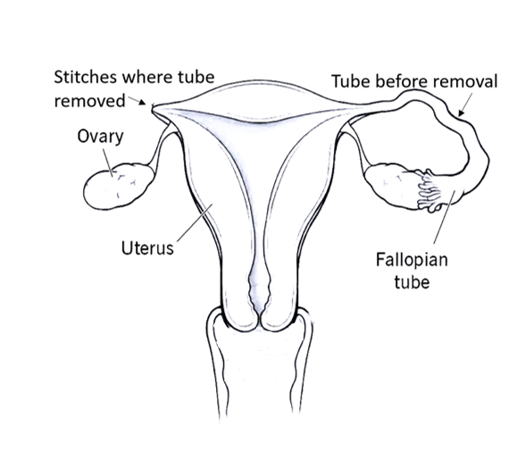  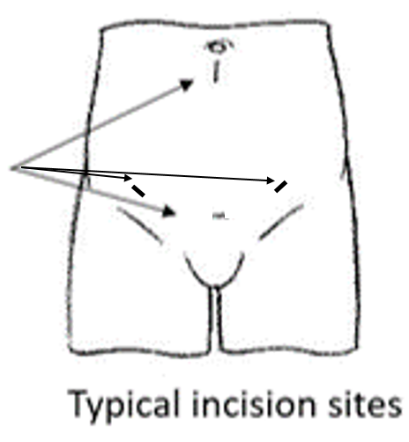 | - Expected 100% success rate (0% pregnancy rate)  - Removes the risk of tubal cancer  - Estimated reduction of ovarian cancer risk by 42-78%  - Lowest risk of tubal ectopic pregnancy  - More suitable for people with previous tubal ectopic pregnancy, tubal surgery or failure of other methods of tubal occlusion | - Reversal procedure is not possible  - Slightly increased operative time )  - May need 1-2 additional cuts in abdomen for additional instruments  - Possible risk of internal bleeding where tube removed  - Possible risk of earlier menopause

- My sterilisation choice

Which surgical option do you prefer? Please check ☑ one
Filshie Clip Sterilisation
Total Removal of the Fallopian Tubes

Please complete the following table, only after you have read the female sterilisation leaflet provided.

Procedure | I would like to have this option because… | I would NOT like to have this option because…
Filshie Clip sterilisation
Total Removal
of the Fallopian Tube

Your signature: ……………………………………………..

Your Name: …………………….………………………..

Date: ……………………………………………..

If you have any further comments regarding our Patient Decision Aid, please write these below:

References

- ACOG Committee Opinion No. 774: Opportunistic Salpingectomy as a Strategy for Epithelial Ovarian Cancer Prevention. Obstetrics and Gynecology [Internet]. 2019 Apr 1;133(4):e279–84. Available from: https://pubmed.ncbi.nlm.nih.gov/30913199/

- FSRH Clinical Guideline: Male and Female Sterilisation (September 2014) - Faculty of Sexual and Reproductive Healthcare [Internet]. Fsrh.org. 2014. Available from: https://www.fsrh.org/standards-and-guidance/documents/cec-ceu-guidance-sterilisation-cpd-sep-2014/

‌

My confidence level in making this choice

- Which surgical option do you prefer? Please check ☑ one and indicate your 2nd and 3rd option.
Filshie Clip Sterilisation
Total Removal of the Fallopian Tubes
Unsure

- Considering the option you prefer, please answer the following questions:

 | Strongly Agree  [0] | Agree  [1] | Neither Agree Or Disagree  [2] | Disagree  [3] | Strongly Disagree  [4]
1. I know which options are available to me.
2. I know the benefits of each option.
3. I know the risks and side effects of each option.
4. I am clear about which benefits matter most to me.
5. I am clear about which risks & side effects matter most.
6. I am clear about which is more important to me (the benefits or the risks and side effects).
7. I have enough support from others to make a choice.
8. I am choosing without pressure from others.
9. I have enough advice to make a choice.
10. I am clear about the best choice for me.
11. I feel sure about what to choose.
12. This decision is easy for me to make.
13. I feel I have made an informed choice.
14. My decision shows what is important to me.
15. I expect to stick with my decision.
16. I am satisfied with my decision.

ecisional Conflict Scale © AM O’Connor, 1993, revised 200

